* Login to Portal azure
* Create a database server (fill in all required information)
  + Uid: khanhn
  + Pwd: [your password]
* Create sql database

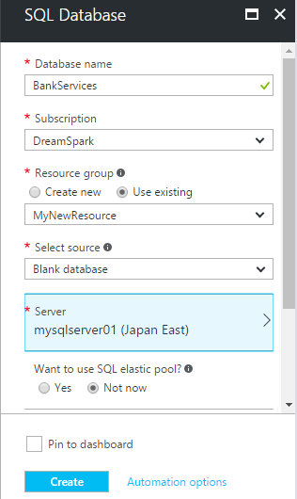

* Create and manage tables, data
  + Open SSMS
  + Enter connection information

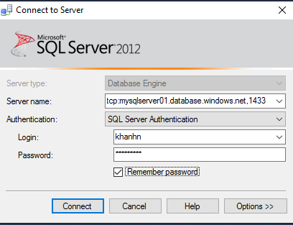

create table accounts

(

accountId int identity primary key,

accountName nvarchar(50) not null,

createdDate datetime default getdate(),

balance decimal

)

insert into accounts(accountname, balance) values(N'Nguyen Khanh',10000000000)

select * from accounts

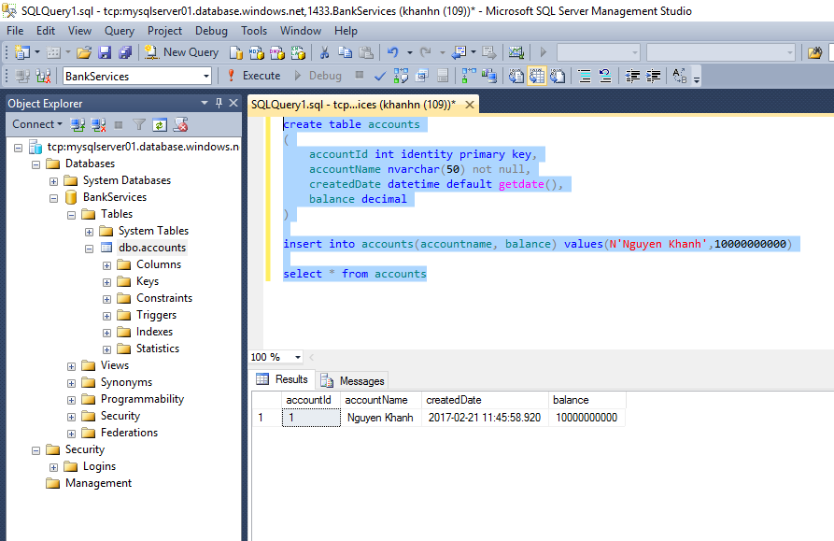

* Get connectionString
* Server=tcp:mysqlserver01.database.windows.net,1433;Initial Catalog=BankServices;Persist Security Info=False;User ID=**khanhn**;Password=**{your password here}**;MultipleActiveResultSets=False;Encrypt=True;TrustServerCertificate=False;Connection Timeout=30;
* Connect to SQL Server after setting firewall

## Create a web application that can use Azure SQL Database

* Create a new Web App > select MVC App
* Create EDM (Database first or code first)

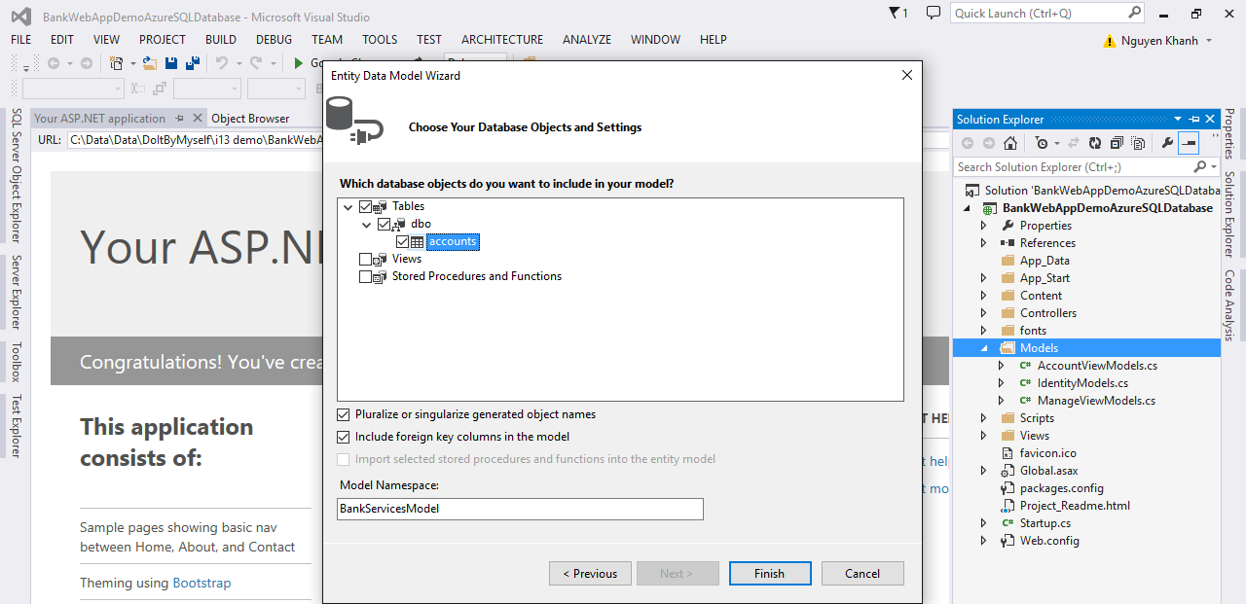

* Build and create a new MVC Controller
* Test app
* Change connection string with Azure connectionString
* Save and Publish to azure cloud

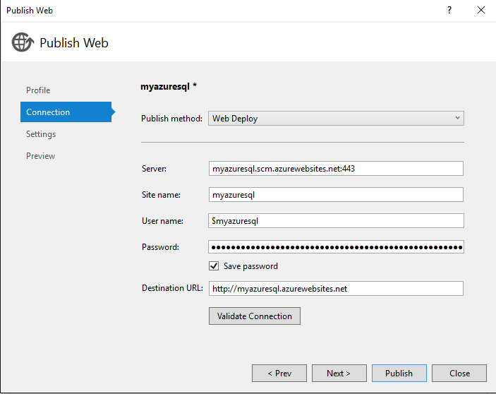

Chuỗi kết nối chạy thành công

<add name="BankServicesEntities" connectionString="metadata=res://*/Models.BankModel.csdl|res://*/Models.BankModel.ssdl|res://*/Models.BankModel.msl;provider=System.Data.SqlClient;provider connection string=&quot;data source=tcp:mysqlserver01.database.windows.net,x;initial catalog=BankServices;persist security info=True;user id=khanhn;password={password}multipleactiveresultsets=True;application name=EntityFramework&quot;" providerName="System.Data.EntityClient" />